William Rose

Quinn M. Lanik

CSCE 155N: Computer Science I

03 May 2021

The main idea behind my final project was to have a very entry level interface that anyone could use for plotting 1 or 2 specific coordinates. Initially, I wanted to make my own GUI for controlling a lighting sequence however, I did not get the idea approved by an LA prior, so I went with the given idea provided by the Professor. My initial design was to implement the basic guideline provided however, I wanted to spruce it up a bit and provide a little more flair. My first incremental design only plotted one set of coordinates and this proved boring, so I added a second input. It was during my second input that the coding became a little cumbersome due to specific logics needing to be set to meet my desired outcome. Another difficulty that I faced came in the fact that I wanted a lot of flexibility within the GUI so that when any modification was made, it would happen in real time and not require that end user to select plot every time. Examples include; when you disable input 1 or input 2 and then re-enable input 1 or input 2. I did not want to force the end user to re-plot each time. My work around for this was to house the logic states within each callback function. Another difficulty I faced was the legend and being able to adjust the “marker” at any point. Initially, it was easy to get the coding to perform the desired function however once I added the ability to disable Input 1 or Input 2 it began finding gaps in the code and would not display the desired “marker”. My work around for this was to establish 3 different display setting (disp1, disp2, and disp3). Once I created these it was a copy and paste fix within the applicable callback functions. As far as data entry goes, I utilize edit fields (text boxes) for some of the components and edit fields (Numeric) for the coordinates. This automatically sends an error message when any non-numerical value is entered, I felt it is a cleaner overall look vs using a pop-up error message. One difficulty that I faced came when I was trying to establish an editable field that automatically links to the graph. I wanted the Title, X-axis label and Y-axis label to be housed within the Graph however, I could not figure out how to make is “editable” so rather, I created editable text blocks within the GUI, and it performs the desired function (however I could not figure out how to rotate the y-axis title).

Outside of this class I work as a systems Engineer within the Aviation Industry. I constantly work with GUI’s; however, this class is the first time I have ever had to develop my own. Typically, I am provided a system definition document by a Software Engineer and I verify that the GUI has all the correct layouts, and that each layout performs its intended function. An example of this would be as follows:

A popular upgrade within the aviation community is upgrading Cabin incandescent lighting to LED style Cabin lighting. The LED bulbs utilize pulse width modulation which basically creates a square wave and turns the LED bulb off and on. Depending how “fast” or “slow” the pulse is will reflect in the “brightness” off the LED. So, one of the more recent projects that I did consisted of the following GUI for cabin upwash and downwash light dimming:

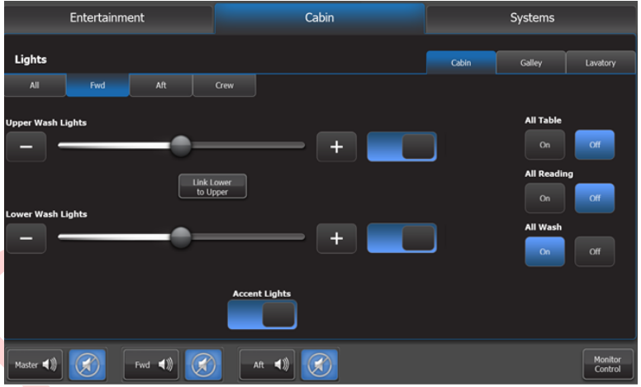

As you can see, the end user gets a relatively easy-to-use interface that allows him to control the on/off status as well as adjust the intensity of the cabin lights. What he does not see is the system functionality which consist of the on/off button which activates a relay and the scroll bar which represents a 0-5k ohm potentiometer within an environmental controller. The resistive value is then fed to a dimmer control module via a dim+ and dim- signal that relates to - 0 ohm resistance =100% brightness and 5k ohms resistance = 30% brightness.

In conclusion, I will say that I see a lot more of my future being centered around GUI’s. More and more Aircraft that I deal with are being upgraded to “clean” interior type designs. No longer do you have rows and rows of mechanical switches rather you might have a 10.1” touchscreen controller with all functions being covered within the touchscreen. The only issue I have with that is the proprietary data and how companies do not allow for modification or access to their data. The GUI I mentioned above as an example cost $10,000 per quote to modify (regardless of complexity).